# Unit 9: Implementing an EAFM Plan

## Student outcome: knowledge of how to develop, implement and monitor an EAFM plan

### Activity 9.1: Assess prior experience in planning and developing management plans. (5 mins)

### Introduction

An EAFM management plan should be a formal or informal arrangement between the main fisheries management authority and stakeholders. The development of a plan is essential for the implementation of EAFM. An EAFM plan should consider the following key components:

1. *Define the scope of the plan*
2. *Define stakeholder engagement strategy*
3. *Compile background information*
4. *Prioritise issues and define objectives*
5. *Select indicators and reference points*
6. *Identify management actions to achieve objectives*
7. *Design process whereby all management actions can be implemented*
8. *Design monitoring program including performance indicators (Unit 10)*
9. *Design a compliance/enforcement program (Unit 10)*
10. *Define the “review and management adaptation” process (Unit 10)*

The rest of this subject is about implementing the steps. Note that the steps are presented in a logical chronology however their implementation will require iteration between the steps. Figure 9.1 provides an overview of this process.

The rest of this subject requires the student to answer the questions either on their own behalf or on behalf of the fisheries management problem they have brought to the classroom. An excellent example that can be presented is the management plan developed by the Buakap village in Morobe Province, PNG (Buakap 2006) .

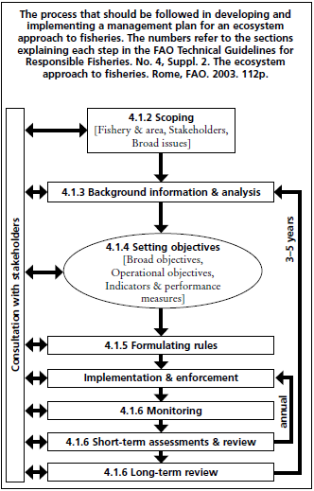

Figure 9.1. Overview of the processes required for the development and implementation of an EAFM plan. Source: FAO, 2005.

#### Define the scope of the plan

One of the very first things you must do in developing a management plan is to decide on the geographic area of the intended management plan (consider both upstream and downstream impacts). This will determine all of the other key elements of your plan. Some of these will be:

* What fisheries are the main interest of this management effort; what are the key species (ensure students address a multi-species fishery to ensure full appreciation of the value of an EAFM); in what habitats do they occur; what areas does fishing occur; what impacts upon the quality of the habitats/status of fished stocks and bycatch.
* Who are the stakeholders? (i.e. anyone with a vested interest in the fisheries of interest. This should consider including local fishers, local fishing community (including non-fishers), other resource users (e.g. tourism operators), neighbouring communities with an interest, external users impacting on the marine environment (e.g. logging companies, palm oil plantations, mining companies, foreign fishers), local government, provincial government, national government, interested NGOs (local, national or international)
* What are the key fisheries-related issues in your area of interest? Breaking these into distinct categories can help this process. For example, think of ecologically-based issues, social issues, economic issues, governance issues, etc. (see Table 9.1 below). For example:
  + Are the fished stocks being used sustainably (consider changes in catch rates over the last 10 or 20 years, changes in average size of fished stocks, changes in species composition)?
  + Are the fishery benefits equitably distributed?
  + What external impacts are detracting from a sustainable fishery?
  + What internal impacts are detracting from a sustainable fishery?
  + In data poor environments, interviews and discussions with local fishers can help determine if there is a problem by asking:
    - How have catch rates (CPUE) changed over the last 10 years? 20 years?
    - How have fish sizes changed over the last 10 years? 20 years?
    - How has the composition of the catch changed over the last 10 years? 20 years?

If there has been a decline in CPUE or the average length of fish caught then the fish stock is probably in decline. Similarly, if the fish caught have changed to include more fish at a lower trophic level, then the fishery is probably in decline.

* Is there current management in place and is it effective (i.e. are the controls in place the right ones)? If not, why not? Is it being effectively implemented (i.e. do people comply with the rules)? If not, why not?
* Who has what kind of jurisdiction in the geographical area that matters? Reference national, provincial and local level laws, policies and plans where appropriate as well as less formal, local management regimes.

Table 9.1: Possible categories of issues to consider under an EAFM (adapted from SPC 2010).

|  |  |
| --- | --- |
| **Ecosystem issues** | |
| • Target species  • Byproduct species  • Bycatch species  - Retained  - Discarded  • Special species (protected species;  vulnerable species)  • Fish community structure  - Trophic structure changes | • Ecosystem/habitat  - Habitat damage from equipment  - Spawning aggregations  - Water quality changes  - Land-based impacts  - Natural impacts (bleaching, earthquakes,  storms, etc.)  - Man-made impacts (dredging, sediment, etc.) |
| **Socio-economic issues: community well-being** | |
| • Fishers  - Income  - Work-related injuries  - Food  - Well-being  • Community  - Employment  - Food  - Fees  - Cost to alternative activities or  opportunities  - Social disputes – resource  ownership, equity, benefits  - Fuel, boats  - Training  - Cultural values and issues  - Climate change  - Natural disasters | • Small-scale commercial sector  - Income, profit  - Work-related injuries  - Risk – storage, shipping  - Community relations  - Fuel, supplies  - Fees and licenses  - Training  - Market price variability  - Demand fluctuations  - Infrastructure  • National  - Management capacity  - Export income  - License fees  - National social and economic plans  - Food security  - Market forces  - Development |
| **Governance** | |
| *Ability to achieve (governance)*  • Institutional  • Legal framework  - National  - Provincial/state  - Local  - Other  • Management plan  • Compliance  • Enforcement  • Monitoring  • Research  • Community leadership and structures  • Resources to manage at national,  provincial and community levels  - Staff capacity  - Financial resources | • Consultation/engagement/participation  - Community  - Industry  - Provinces / states  - Interagency  - NGOs  • Reporting  • Information and awareness  • Interagency cooperation and coordination  • Community – national agency cooperation  *External factors (natural and human induced)*  • External drivers affecting governance (fisheries and non-fisheries sources)  - Climate change impacts (bleaching, etc.)  - Catchment impacts (coastal development, agriculture, mining, logging)  - Marine development (e.g. tourism related, marine oil/gas)  - Market forces |

### Activity 9.2: Using the EAFM plan template ask students to outline the scope for their case study EAFM plan and list the key issues for the fishery/ies. This can be done as individuals, in pairs or in groups depending on the class. (50 mins)

#### Define stakeholder engagement strategy

Stakeholder involvement in the EAFM process is critical to the success of the plan. Without stakeholder ’ownership‘ in what the EAFM plan is trying to achieve, and an understanding of the reasons why, then the fishing community/ies is/are not likely to accept or follow the plan. Thought needs to go into this process and so a plan for engagement needs to be developed. Broadly, this is about who to include at what stages in the process and how. Planners need to decide the levels of input they desire from stakeholders regarding decision-making. This may be restricted due to resources or the culture of the organisation(s) you are dealing with. Pros and cons of various ways forward must be considered.

For each stakeholder group, the engagement strategy needs to consider:

* what do we want to achieve with this stakeholder group,
* how best to achieve this,
* what key messages do we want to share,
* what messages will they want to share,
* what inputs do we want from them,
* when do we want these inputs,
* how best to share messages,
* how best to garner inputs,
* what is the feedback loop,
* what are the likely problems and benefits of the chosen approach.

### Activity 9.3: In your EAFM plan i) List the relevant stakeholders for your case study, and ii) Develop your stakeholder engagement strategy using the template as a guide. (40 mins)

#### Compile background information

With consideration to the issues identified above, the geographical area and the stakeholders involved, all available information on the fishery/ies, the ecosystem and the people depending on them, should be compiled and analysed. This process will help in the formulation of the plans detailed objectives. Information sources may be documents or oral history.

The type of information that needs to be collected during this step includes:

*Social and economic aspects of the fishery/ies* – the level of employment; value of the fishery to local and national economies; subsistence and cultural importance; ownership of the resource (access rights).

*Fishery characteristics* – area of operation; gears used; vessel types; target and bycatch species; species biology and ecology; catch composition; monitoring data available.

*Ecosystem* – description of habitats; potential upstream and downstream influences; data available.

*Governance* - legal frameworks; management plans; national-local arrangments.

Provide information here about existing management (refer to PNG and SI Fisheries Management Information on EAFM CD under References, then Further Reading).

### Activity 9.4: Identify potential sources for background information. This only needs to be a list due to time constraints to demonstrate key sources are identified. Some of these will be on the EAFM CD (eg. legislation and policy, status reports, research reports, etc). (15 mins)

#### Prioritise issues and define objectives

The steps involved in translating overarching policy and goals into operational objectives and actions is seen below (Figure 9.2).



Figure 9.2. Process for translating high level policy to broad objectives of the EAFM plan, through to operational objectives and actions. (Source: FAO, 2005).

*Broad objectives*

Broad objectives must be set first, and subordinate and more detailed objectives can then be set. As these broad objectives should be consistent with national policies (eg. sustainable fishing), they are very important as they provide statements of the overarching intended outcomes of the management plan. These objectives should cover all of the dimensions: economic, social, cultural, and environmental. It is important that all levels of stakeholders be involved in the setting of these objectives. Examples of broad objectives are:

* Maintain target species within ecologically viable stock levels.
* Maintain habitats and non-retained fishery species within ecologically viable levels.
* Maintain healthy structure and function of ecosystems.
* Ensure equitable sharing of the resource among stakeholders.
* Maximise economic benefits.

In PNG, the Buakap village in Morobe Province developed their own management plan with the overarching goal to “*Protect the marine environment and fisheries resources for the future generations.* ” Such a broad statement sets the scene for more specific objectives to be formulated.

An example of broad objectives and corresponding lower level subordinate objectives from the Caribbean (Fernandes, 1996) is given in Figure 9.3 below. Subordinate objectives all contribute to the higher-level objective above them.



Figure 9.3 Community-derived objectives for Saba Marine Park, structured into an objectives hierarchy. Numbers in parentheses are the default weightings (importance) given to each objectives when presuming all objectives are equally important to achieving the overall goal.

### Activity 9.5: Identify broad objectives for your case study EAFM plan. (20 mins)

*Prioritise issues*

Operational objectives can usually be grouped into each of the different broad objectives and are very specific with much more detail. They will also directly address the fishery issues identified earlier. However, there is a limit to how many fisheries issues that can be practically achieved concurrently. Therefore, you ***firstly*** need to prioritise the issues to ensure that management efforts focus on the most important issues. FAO (2005) suggest this prioritisation involves three tasks:

**Task 1:** Under each of the broad objectives group the detailed fishery issues already identified.

**Task 2:** Prioritise the issues based on the level of risk they pose to the fishery.

**Task 3:** Develop operational objectives only for the priority issues.

*Identification* involves listing all of the key issues and *prioritisation* involves judging the severity of threats associated with each (SPC, 2010). In identifying issues remember to consider all possible interactions between a fishery and the ecosystem.

### Activity 9.6: Assign previously identified fishery issues to each broad objective. In small classes this works better in groups as more issues will be identified which will make Activity 9.7 easier also. This also better reflects the likely scenario when asking for community input into issue identification where many issues will be identified. (20 mins)

Prioritisation can be conducted using qualitative and opinion-based risk assessment methods through to more quantitative data-based ones, depending upon student capabilities. Two different approaches are provided below using fishing related issues as examples, however, non-fishing issues and socio-economic issues could be assessed using the same methods. Tables for using a qualitative approach or a quantitative approach are provided in the EAFM plan template.

Example 1

Pairwise ranking of issues (simple):

|  |  |  |  |  |  |  |
| --- | --- | --- | --- | --- | --- | --- |
|  | Issue 1 | Issue 2 | Issue 3 | Issue 4 | Issue 5 | etc |
| Issue 1 |  |  |  |  |  |  |
| Issue 2 |  |  |  |  |  |  |
| Issue 3 |  |  |  |  |  |  |
| Issue 4 |  |  |  |  |  |  |
| Issue 5 |  |  |  |  |  |  |
| etc |  |  |  |  |  |  |

Compare each issue with the other e.g. Issue 2 with Issue 1. Write, in the blank white space, which one of the two is most important. Those issues that are written down most often, in the table, are the most important issues. See Box 7 below for a worked example from Ref#EAFM1.

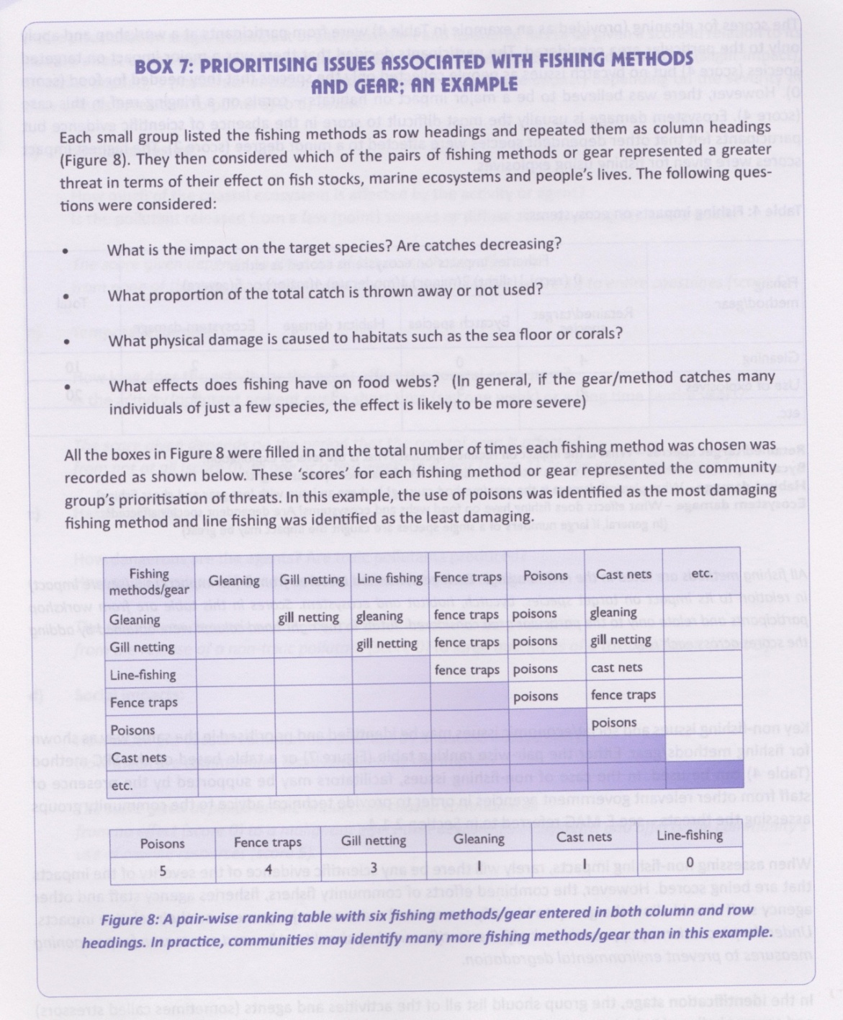

Source: SPC, 2010 (EAFM1).

Example 2

Quantitative approach adopted by SPC:

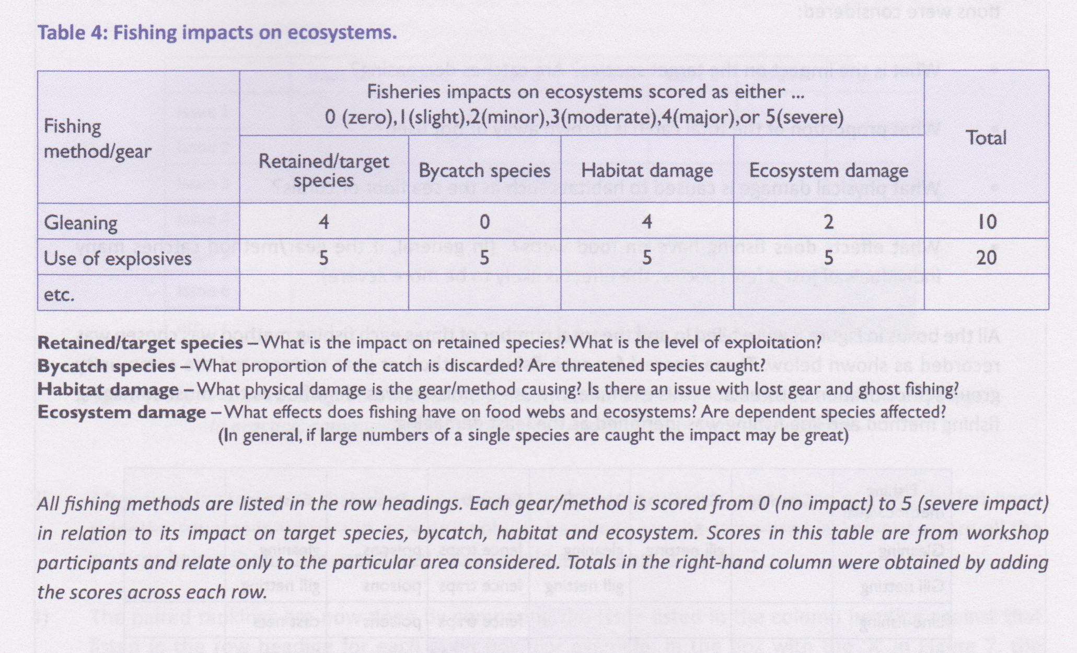

Source: SPC, 2010 (EAFM1).

***Advanced students:***

A more rigorous assessment process can be adapted from SPC 2010 (EAFM1) – pages 26-27. There are two ways to prioritise the issues – one is to apply the risk analysis as indicated in the SPC guidelines to the threats and prioritise the objectives with regard to how well they address the priority threats. The other is to prioritise the objectives themselves by slightly adapting the assessment framework to refer to the likely impact of achieving the objective across: spatial, temporal, threat abatement, social importance dimensions (where 1 is a small impact and 5 is a large impact) and feasibility. So the highest score an objective could have is 25 and the lowest is 5. You might also consider one other factor in this assessment (in a separate column): the certainty with which you are applying these numbers (1 is low certainty and 5 is high certainty).

**\*The EAFM plan should document each of the issues identified, the level of priority given to each and how they were given the level of priority.**

### Activity 9.7: Prioritise issues for your case study using either a qualitative or quantitative risk assessment method. Use the templates provided. (35 mins)

*Operational objectives*

For each of the issues identified as being the highest priority an operational objective should be developed that addresses the issue. These objectives should be measurable and achievable. For example, if one of the fishery issues identied as a high priority is that “catches of the target species are dropping“, then an operational objective would be “to increase the catch of the target species“. In an EAFM context these objectives should be ecological, social and economic however can also refer to single species if a key issue relates to them. Once again, it is very important to have stakeholder involvement in identifying these objectives.

Further reading: Pomeroy et al., 2004 provides many examples of biophysical, socio-economic and governance operational objectives and relevant performance measures.

### Activity 9.8: Develop operational objectives for your case study EAFM plan for the priority issues. Focus on the top 3-4 initially. Use the objectives templates provided in the EAFM plan template. (25 mins)

#### Select indicators and reference points

Indicators (or performance measures) and reference points were introduced in Unit 8. The whole aim of setting these in our plan is so we have measureable attributes that we can use to assess how well our EAFM plan is achieving its stated objectives. At least one indicator, and reference points for each indicator, should be selected for each operational objective. Ultimately it is very important that there is the capacity for the indicator to be measured and monitored regularly, and that the indicator is meaningful to stakeholders. Below is a fisheries example from SPC (2010) of the use of an indicator and reference levels.

Further reading: Pomeroy et al., 2004 provides many examples of biophysical, socio-economic and governance operational objectives and relevant performance measures.

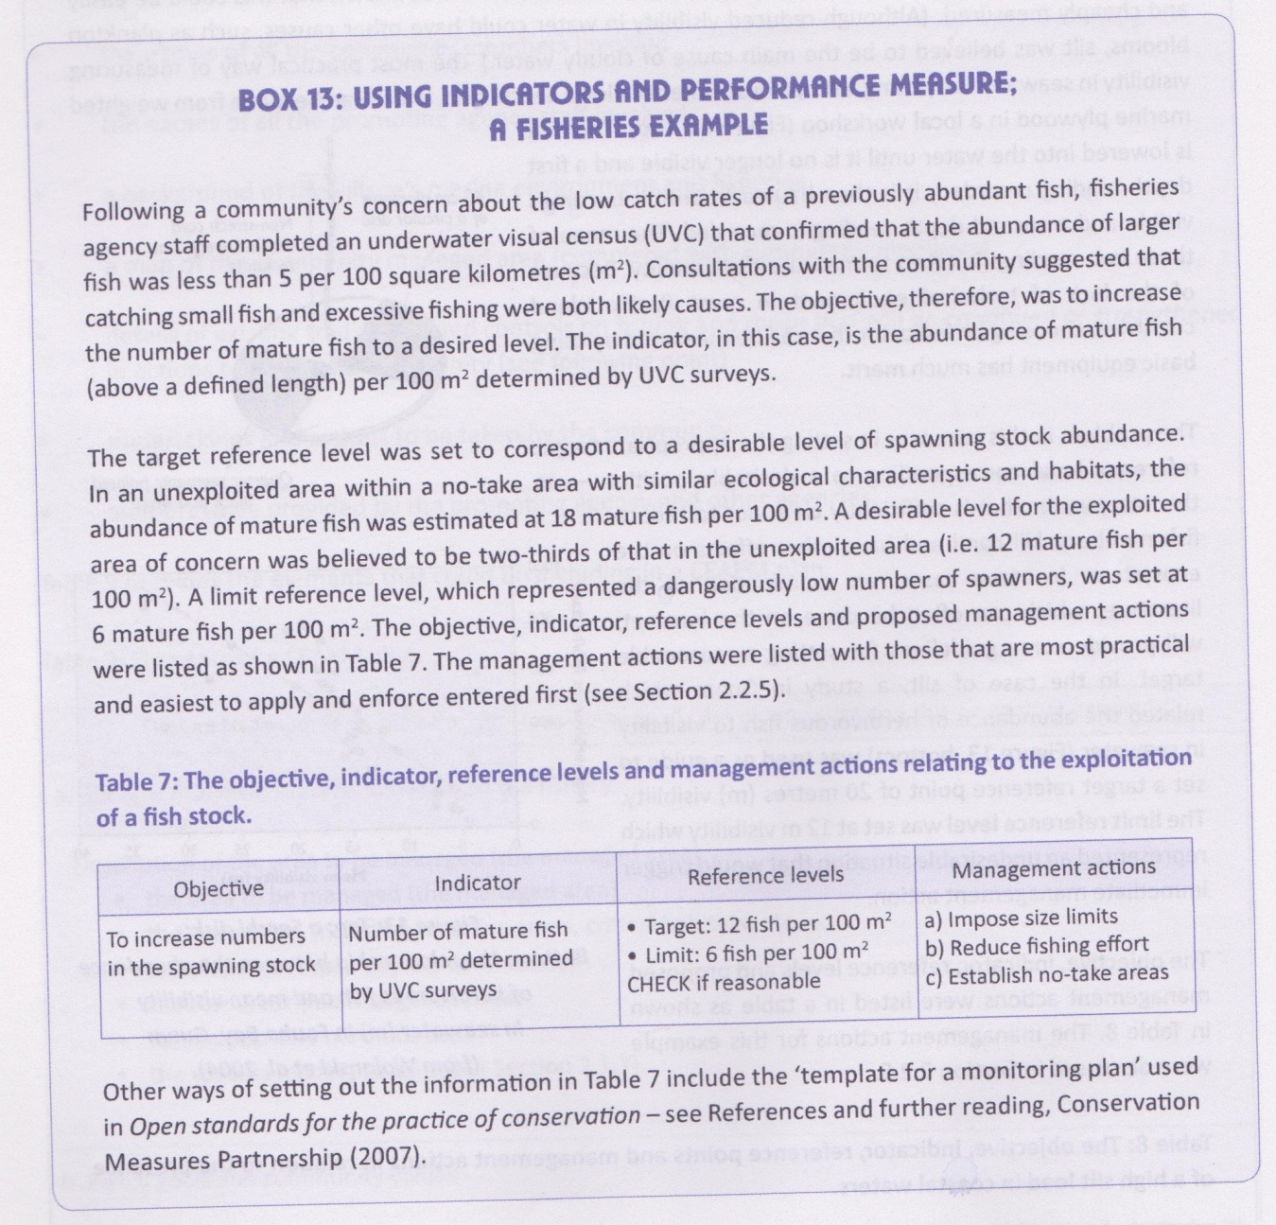

Source: SPC, 2010.

### Activity 9.9: Identify potential indicators that may be used for assessing each objective. Use the objectives table in the EAFM template. (15 mins)

#### Identify management actions to achieve objectives

Management actions are the measures needed to achieve the objectives and there will quite often be more than one required to achieve a particular objective, as shown in the above example. A good way to identify the potential management actions for each objective is for members of the local community, along with relevant government and non-government agencies, to participate in a brainstorming session. To help in choosing the most appropriate management actions the following factors should be considered for each: ease of application, likelihood of success, feasibility and cost (SPC, 2010). Some management measures will be identified for many different objectives. In multi-species fisheries it will be impossible to manage for each species separately so there must be consideration to the general state of the resources overall with attention given to low productivity species as well as high productivity species. As much as possible, management actions should have minimal undesirable impacts on the operational objectives. All management actions should also refer to those responsible for their implementation.

A list of potential management actions (input and output controls) are listed in Unit 2 of this course. Also see:

FAO 2005 - P14-29

SPC 2010 - Table 6, p 32

Albert et al 2010 - P 48-59

### Activity 9.10: Identify potential management actions that could be used to achieve each operational objective. (45 mins)

### Justify your choices using the criteria:

### - Ease of application

### - Likelihood of success

### - Feasibility

### - Cost

#### Design process whereby all management actions can be implemented

To be able to successfuly implement the EAFM plan, ALL of the above elements need to be documented in a written plan (see EAFM plan template on EAFM CD). The plan should consider and include all necessary details including: the exact nature of management actions, who implements them, how they will be applied and when, what formal and informal legal and administrative structures need to be put in place, what is the role of government and other agencies, what is the role fo the community, what will implementation cost, who will fund it, etc.

Ideally, through cooperation between government and the stakeholders, there will be a formal recognition and acceptance of the plan at all levels (see the Apia Policy). Other elements of the plan that also need to be documented are compliance and monitoring. These elements are a critical part of the plan review process and are discussed further in Unit 10.

### Activity 9.11: Using the EAFM plan template document all the above elements into an EAFM plan for your case study. Include identification of factors needed to be considered to formalise the plan, and how they may be addressed. Butchers paper may be useful for groups. (20 mins)

**Further reading:**

Buakap Salamaua management plan (2006). Coastal Fisheries Management and Development Project. (on CD under PNG Fisheries Information)

FAO. (2010) Putting into practice an ecosystem approach to managing sea cucumber fisheries. Food and Agriculture Organisation, Rome. 81pp. (Ref # EAFM3)

Pacific Islands regional coastal fisheries management policy and strategic actions (*The Apia Policy*).<http://www.spc.int/DigitalLibrary/Doc/FAME/Reports/Anon_2008_ApiaPolicy.pdf> (5MB!)

# Unit 10: Compliance, Monitoring and Plan review

## Student outcomes: ability to develop and implement monitoring and compliance plans to support an EAFM plan, and apply adaptive management

### Activity 10.1: Ask the class to break into 2-3 groups and document prior experience and local examples of compliance and monitoring activities. Get them to report back to the class.

### What does adaptive management involve? (20 mins)

### Introduction

The following elements (monitoring, compliance and plan review) are all important parts of the EAFM plan and should also be documented as part of the plan. The monitoring component is very important is it provides the necessary information to assess how well the plan is performing against the objectives. The monitoring process should also consider how well the plans management actions are followed by the stakeholders (compliance – see below). To make sure that this monitoring process feeds into the plan and informs how the plan needs to be changed (or not), a review process also needs to be developed. This is discussed in the final section of this unit.

#### Design a monitoring program

#### Define monitoring program

The EAFM plan needs to include a process for monitoring the success of the plan. This process should then be documented in a monitoring plan to help ensure it is acted on. The monitoring program will be dictated by the issues identified and prioritised earlier, thereby helping to evaluate the success in meeting the operational management objectives. The monitoring process will need to:

* Identify performance measures and reference levels for each of the operational objectives (discussed and developed in Unit 8, 9 and below in more detail);
* Identify data to be collected and the collection methods (refer to Unit 8 and remember to include data on social and economic characteristics);
* Document a plan for conducting the data collection (eg. When, where, who, how; refer to Unit 8);
* Identify how the data will be analysed (who, when; refer to Unit 8).

Ultimately the data collected from monitoring will need to be formally considered during the review process. In developing a monitoring program, guidelines that complement the text here are provided in the EAFM plan template. In developing a robust monitoring program sampling design, relevant expertise should be consulted as much as possible.

Principles of good monitoring design:

* Spread sampling throughout area of interest
* Use replication to account for natural variability – the more the better (see Figure 10.1)
* Minimise sources of variation
  + Eg. fish numbers can be influenced by season, tide, time of day, depth, reef zone, water temperature, visibility, etc.
* Identify who will conduct monitoring and when
* Develop robust data storage and analysis procedures



Figure 10.1. The importance of having replicate sampling sites in your monitoring is demonstrated here by showing the potential for incorrect conclusions that can be made without replication. Source: English et al, 1997.

#### More on indicators

Performance indicators are the yardsticks by which one can measure, or estimate, the degree of achievement of different objectives. Performance indicators may be quantitative or qualitative.

The most important characteristics of the indicators suggested here are that they must be:

* representative of the system of interest;
* sensitive to temporal and spatial rates of change;
* unbiased;
* feasible with respect to data collection; and
* easy to interpret by the various user groups that will use them.

Indicators should be **representative** of the objective of interest (Liverman et al. 1988); that is, they should accurately represent the state of achievement of the objective or include an explicit range of uncertainty (Braat 1991). A good indicator should be **sensitive to change**, ie. it should be able to discern normal variability from movements towards or from a desirable situation (Liverman et al. 1988). Data for the indicator must be collected frequently enough so that significant changes can be detected within the time frame of interest (MacDonald 1972). Ideally, long- as well as short-term trends should be detectable (**temporal scales of change**). In addition, indicators should be sensitive to **spatial scales** **of change** (Liverman et al. 1988, MacDonald 1972). If the problem of spatial heterogeneity is anticipated then it can be pre-empted, to some degree, by stratification of data collection and combination. Thus, both spatially and temporally, the dimensions and size of the indicator should show the degree of deviation from a steady state and the distance from a desirable situation (Opschoor and Reijnders 1991).

It is impossible to establish totally **unbiased** indicators (Liverman et al. 1988). Value judgements enter into every stage of indicator construction: what, where, how, when to measure, how to weigh and present the results? Every effort should be made to minimise these biases (Liverman et al. 1988).

The data required for indicators should be **feasible to collect** (MacDonald 1972, Liverman et al. 1988). In many cases, existing or proposed monitoring systems could be used. One constraint on the choice of monitoring systems may be the necessity to follow long-term trends in conditions.

Indicators should be **easy to interpret** by the various groups that will use them (MacDonald 1988, Kuik and Verbruggen 1991). A reduction in precision may have to be accepted to facilitate communication of indicators. Their communication can be further improved with the use of graphics and computer demonstrations. One aspect to consider is that the decision-making process is usually receptive to the presentation of indicators in terms of costs and benefits (Kimball 1972).

***Advanced students:***

*Application of indicators*

In addition to the above technical selection criteria, the usefulness of the indicators will be enhanced if they have predictive power, if they are politically and/or socially meaningful, and if they have clear implications for policy. It is recognised that it is unlikely that all indicators will be able to meet all of these criteria; it is therefore particularly important that the process of indicator development or construction is transparent.

Indicators that can **predict** or anticipate undesirable conditions, for instance, have great value to managers. This is possible if the indicator reflects a link between cause and effect (Gilbert and Feenstra 1992). For example, if biological indicators can be used to measure the responses of organisms to environmental quality, then it may be possible to predict a biological response from a physical measurement (Thomas 1972). Time series data may be used in predictive extrapolation or simulation modelling (Liverman et al. 1988).

Performance indicators are also more useful if they have immediate **political or social meaning** (Goldstein 1972, Liverman et al. 1988, de Haes et al. 1991). For example, pollution may be measured at source, but the effect of that pollutant on a biotic receptor is more likely to be socially and politically meaningful. From a scientific point of view, however, the validity of biological indicators is a major problem in that knowledge of specific environmental effects, especially those arising from a combination of impacts, is often very limited (Finklea et al. 1972, Liverman et al. 1988).

In representing some part of a chain of cause and effect, an indicator should offer **implications for policy**. Determining the effectiveness of a past policy or options for future policy should be assisted by following the trends in indicators.

Not all of the potential problems associated with the selection of indicators can be avoided, but a **transparent process of indicator development** will permit improvements and enable decision makers to make allowances for their deficiencies.

In some cases, proxy (or surrogate) performance indicators have to be used to measure more nebulous qualitative effects (eg., number of lessons at school may be used to measure increased awareness and understanding). One expects, however, that the proxy is highly correlated with the effect (French 1988). Obviously this is not ideal but it provides some measure of guidance.

*Units of measurement of performance indicators*

It is essential, in defining the performance indicator, to specify the units or scale along which one is measuring achievement (Weber and Borcherding 1993). Measurement of the achievements of a project with respect to different objectives result in scores. These may be made along a "natural" pre‑existing interval (eg., degrees Celsius temperature) or ratio scale (eg., the real numbers used to measure weight). Alternatively, qualitative measures can be used or else experts’ opinions. For example, in the absence of further information water quality can be designated as poor, satisfactory or good.

*Reference values*

Reference values give meaning to the units measured in performance indicators. Reference values tell you whether any particular level or direction of a performance indicator is good or not. Reference values also provide a base upon which lowest-level objectives can be normalised and compared to each other. All performance indicators should be feasible in the sense that reference values can be determined.

What kinds of reference values are there?

**Desirable level** of achievement - this is the ideal level of achievement of an objective. This might be the ideal level that you or the community aim to achieve. More likely is that, because there are often multiple impacts upon an objective, anything anyone agent might do can only move the needle so far in terms of achieving this objective. Thus, for the community this “desirable level” may not be achievable through their actions alone. None-the-less, identifying what is the more desirable condition is important.

**Target values** – are attainable levels of achievement of an objective. They are levels that should be reached within specified time frames by the people you are working with e.g. the community eg. 1, 5 or 10 years.

**Undesirable levels of achievement** – this a level which should never be reached and is unacceptable to the parties involved.

**Trigger values** – it may be that you are not at an “undesirable level” of achievement but you are declining in the degree to which you are achieving an objective and your have reaches a level where there is cause for concern and management action is required immediately. This is called a “trigger value” as it should trigger a management response. Trigger values are crucial because, when you are dealing with many objectives, a decline in one may be overlooked if the other objectives area going fine.

Via these reference values, performance indicators measure the distance between a current or predicted value and a value that is considered meaningful in some way.

**Collecting data to assess level of performance indicators** (teacher to extract most applicable information from Pomeroy et al 2004– although this book refers to MPAs the management effectiveness measures laid out can be applied to any management efforts with similar goals).

Suggest use parts of the section in Pomeroy et al 2004 called “MPA management effectiveness indicators”.

For biophysical indicators read pages 47-53, **choose one or two** biophysical indicators from biophysical indicators number 1 page 55, no7 page 94, no8 page 100, no 9 page 104, no 10 page 107;

For socio-economic indicators read p113-117 and **choose one or two** socio-economic indicators from socio-economic indicators no’s . 1 through to 5 pages 119-130.

For governance indicators read p163-165 and **choose one or two** governance indicators from governance indicators no.2 through to 6 pages 169-179, indicator no 9 (p186-187), 13, 14, 15 pages 196-201.

### Activity 10.2: Ask students to design a fisheries data collection program appropriate for their case study. Use the monitoring program guidelines provided in the EAFM plan template and refer to the operational objectives and the indicators identified during Unit 9. Modify these as needed. Include objectives of the monitoring plan. (40 mins)

**Further reading (Monitoring):**

Johnson, J. (2010) Vulnerability and adaptation of coastal fisheries to climate change: monitoring indicators and survey design for implementation in the Pacific. C2O Consulting – coasts climate oceans. Report for the Secretariat of the Pacific Community, New Caledonia.

MRAG (2010) Monitoring the vulnerability and adaptation of Pacific coastal fisheries to climate chnage. Report prepared for the Secretariat of the Pacific Community, Marine Resources Division, New Caledonia.

Pomeroy, RS, Parks, JE and Watson, LM (2004) How is your MPA doing? A guidebook of natural and social indicators for evaluating Marine Protected Area managament effectiveness. IUCN, Gland, Switzerland and Cambridge, UK. *xvi* + 216p.

#### Design a compliance/enforcement program

Building a natural resource management plan together with local communities and users of the resource will facilitate compliance because the resource users will have more ownership of the plan. Even better is when the management planning effort originates with communities. None-the-less, there will always be a level of non-compliance although the degree of non-compliance will be low for most people. Only a few might fail to stick to the rules on purpose (Figure 10.1).

Where people fail to stick to the rules on purpose, it can be important to understand why they are non-compliant. Is it because they don’t agree with the rules or they can’t afford to stick to the rules (e.g. if they don’t catch the extra fish then they can’t pay the school fees). These motivations can influence, on a case-by-case basis, the response by management.

After the management plan is in place, compliance can be encouraged through the following actions:

**Education** – about the rules and also about the reasons for the rules. This can occur at schools as well as at other forums (e.g. gatherings where people who use the resource come together). This will help prevent accidental non-compliance.

**Routine surveillance** (Cruise and peruse) – like police, it can be beneficial for the management body to have an on-the-water presence in the marine managed area. This raises the profile of the management plan and encourages resource users to ensure they know the rules. If possible, this type of surveillance should never be predictable to the resource user; it should be as random as possible. This will help deter those who might consider breaking the rules if they observe no enforcement activities.

**Targeting of specific behaviours** that lead to opportunistic or intentional non-compliance – identify the times/locations/species/issues that are the focus of non-compliant behaviour and focus limited surveillance and enforcement resources to those times/locations/issues and/or species.

**Punishment of those conducting illegal activities**. The deterrent used to prevent or stop further activities that are against the rules must be sufficient to achieve the goal of encouraging compliance. The sanction need not be a financial punishment. It may be infringements on rights, either permanently or temporarily (e.g. the person is not allowed to fish for a certain length of time).

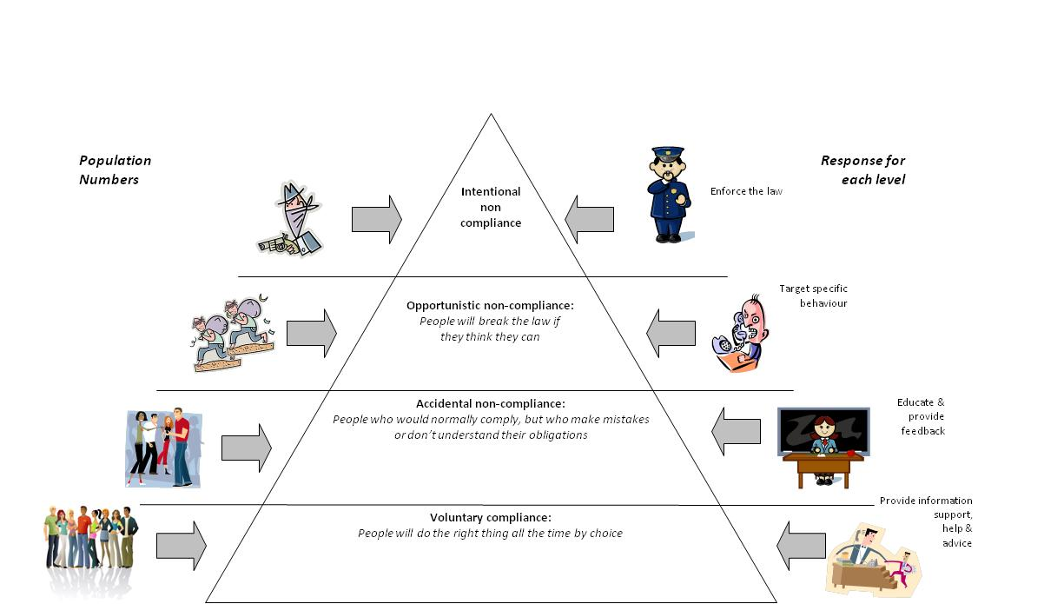

Figure 10.1. Compliance pyramid – Motivations and responses to facilitate compliance (adapted from Gunningham and Grabosky, 1998 p.397 in Greenfield 2009)

**Who conducts the compliance activities?**

The compliance activities can be conducted by a range of organisations/groups as long as they are appropriately empowered to do so. These might include locally anointed rangers given this power by community leaders or more formal entities (e.g. staff of the management organisation, local police, Navy, etc).

Education of the community using the resources is one part of compliance. This can be conducted by the management group or could be devolved, in part, to existing training/education institutions, where appropriate.

Surveillance activities must be conducted by people who have either formal or informal powers to act if they discover illegal activities.

**A risk-based approach to enforcement activities**

Targeting specific behaviours – a risk-based approach should be taken to prioritising the allocation of limited resources available for enforcement. This means assessing:

1. Which illegal activities (in total) are most damaging to the resources?
2. Which illegal activities will enforcement efforts succeed in stopping?

The next steps in the risk-based approach to enforcement is to determine which times/places to deploy enforcement efforts to maximise the chance of apprehending those breaking the rules. This will usually NOT mean regular surveillance of the managed area but rather targeted enforcement efforts which are planned without the knowledge of those conducting the illegal activities.

Very few places in the world have the resources to ensure compliance to resource management through heavy enforcement activities. High levels of voluntary compliance are required. Whilst education can be helpful to ensure voluntary compliance for many people, other people need deterrents.

Being caught doing the wrong thing can, in itself, be an adequate deterrent for some people. But for others, it will be important that the sanction imposed is high enough to deter their illegal activities. This is especially important in situations where the risk of being caught doing the wrong thing is low. If the penalty is high enough then this can be adequate to deter illegal activity despite the low risk of being caught.

**Crime scene investigation approach**

Environmental crimes can and should be subjected to investigation. There has been an unfortunate tradition, in enforcement of marine resource rules, that those breaking the rules must be “caught in the act”. This is not the case for almost any other type of breach of rules or regulations. Rather, enforcement officers can gather evidence, including conducting interviews with witnesses and “the accused” person in order to build a case against someone who has done the wrong thing. This investigative approach is advocated when aiming to enforce an ecosystem approach to management planning.

**Rewarding good behaviour**

Sticking to the rules can also be encouraged through rewards for good behaviour. Whether a reward system might work, or what kind of reward system might work, depends upon each individual situation.

Rewards would usually not be monetary. Rewards might be in terms of an award or prize (a recognition scheme), it might be a form of certification or it might be improvements in access to the marine resource which do not, in any way, diminish the resource. For example, if permission to take certain species is required to be renewed annually, then “good behaviour” might mean that the renewal might only be required every two years.

**Coordinating compliance efforts and centralising information**

Sometimes different groups of people or different organisations are conducting surveillance in the same area for different purposes. By identifying these different groups and coordinating activities, it might be possible to conduct surveillance trips with multiple objectives, rather than surveillance aimed at only one purpose. For example, if the Navy, or Customs, or Water Police, or local rangers or local police all spend some time in an area conducting surveillance and they see activities of interest to each other it would be useful if they shared this information.

This can best be conducted via one centralised locus for depositing information, which all these groups can then access. This might be a community leader or else one of the groups or organisations involved – probably the one with the most resources to keep track of incoming information.

**Training those who are supporting compliance**

The rules of the management plan must be well understood by those in the role of supporting compliance. This includes, also, those who will sit in judgement of people who break the rules. These may be part of a formal legal system or local community leaders.

If the enforcement activities are part of a formal legal system, then compliance officers must be informed as to the appropriate manner in which to collect information (evidence) to use to prosecute accused persons.

If enforcement activities are not part of a formal legal system, then compliance officers must understand and adhere to the community leaders and community norms in terms of collecting information about those who break the rules.

Particular aspects of the severity of illegal activities that should be highlighted to compliance officers and those sitting in judgement of accused persons (whether part of a legal structure or local leaders) include:

* Inequity of allowing some the benefits of illegal access to resources and not others
* Reduction of the benefits potentially accruing to all resource users due to non-compliance
* Erosion of the integrity of the management plan as a whole, due to even a small number of illegal uses occurring

These factors must be considered when decisions are made about appropriate levels and types of punishment to ensure adequate punishments are handed down.

**Funding the compliance activities**

Much as the development of the management plan should include addressing sustainable funding, so too must sustainable funding be sourced to support compliance activities from education to enforcement.

### Activity 10.3: Use the EAFM plan template to develop a compliance program for your case study EAFM plan. (30 mins)

**Further reading (Compliance):**

Greenfield, R. 2009. Facilitating compliance with natural resource management regulations. Findings from Research Cycle 2: expert perceptions of compliance and non-compliance. Department of Environment and Resource Management, Brisbane. 2

Smith, R. G. and K. Anderson. 2004. Understanding Non-compliance in the Marine Environment *in* Australian Institute of Criminology, editor. Australian Government, Canberra. 2

#### Develop the “review and management adaptation” process

A review process is necessary in assessing how well performance measures meet the plan objectives. Reviews should be short- and long-term and be clearly identified in the EAFM plan (see Figure 9.1). Reviews should involve all stakeholders and should use all available and relevant information obtained during the review period, either from external sources or through the monitoring program set up as part of the implementation.

If the monitoring process identifies that a particular objective is not being achieved then management effectiveness (or governance issues) need to be examined. For example, are managment actions being implemented? Are regulations being enforced effectively? If the answers to either of these questions is ‘no‘ then they need to be addressed. If the answers to both of these questions is ‘yes‘ then other or additional management actions need to be considered (SPC, 2010).

This is called adaptive management and is an important part of incorporating learning into the management process, and in ultimately achieving successful management. Short-term reviews should be approximately annual and long-term reviews should be carried out every 3-5 years and will involve a more comprehensive assessment of the success of the plan (Figure 9.1). This stage may involve a re-evaluation of the entire plan including the relevance of the operational objectives. It will need to examine all possible reasons to explain where a plan is not working, and where it is working.

### Activity 10.4: Update EAFM plan with a timeframe and process for review of management effectiveness. If needed refer back to Figure 9.1 for how you might develop your plan review process. (15 mins)

**Further reading (Review):**

Pomeroy, RS, Parks, JE and Watson, LM (2004) How is your MPA doing? A guidebook of natural and social indicators for evaluating Marine Protected Area managament effectiveness. IUCN, Gland, Switzerland and Cambridge, UK. *xvi* + 216p.

# GLOSSARY TEST (Assessable)

### Answer in your exercise books 3 (three) of the following:

### Define “connectivity”

### List and describe 3 major fishery threats

### Define “ecosystem”

### List and describe 3 management tools

### Define “productivity”

#### Final words

Some principles proposed by SPC (2010) for community-based EAFM are worth remembering as you go through the process of developing your own EAFM plan. Although they are targeted to a community-based approach, they are generally relevant for any EAFM approach:

**Keep the process simple:** The process and reasons for management actions, or undertakings, have to be understood at the community level.

**Respect local customs and protocols:** The local traditions and customs must be respected if the process to implement EAFM is to succeed.

**Provide motivation:** Most communities have a good understanding of problems that are affecting their fisheries and the marine environment. The major need is to motivate communities to address these problems.

**Maximise community participation:** All sectors of the community, including youths, women, and community leaders should be encouraged to participate. Most community members are involved in fishing.

**Make use of traditional knowledge:** The knowledge held by older members of the community is likely to be valuable in proposing management actions.

**Use science to support community objectives:** Technical advice and information should be made available to community members. Examples include providing recommendations on size limits of fish, advice on the likely source and effects of existing pollutants, and on ways of improving the wellbeing of community members.

**Enlist the support of a broad range of government agencies:** Many issues affecting a community will be beyond the control of the community. The maximum participation of stakeholders, including a broad range of government agencies, is important in the EAFM process.

**Use a demand-based system:** Work with communities that are aware of their problems and keen to take actions to resolve them. As the resources of most fisheries agencies and other promoting agencies are limited, it makes sense to work with communities that are eager to take local actions. Less committed communities may eventually see the benefits and request to join the programme.

**Adopt a precautionary approach:** Encourage communities to take precautionary actions or undertakings without waiting for scientific confirmation of what is generally known.

**Manage human activities:** Most management is about regulating human activities – activities that are reducing stocks of fish and polluting coastal ecosystems need to be regulated.

**Suggest alternatives to the overexploitation of resources:** Wherever possible, suggest alternatives to the overexploitation of resources. These may include the diversion of fishing pressure from lagoons to offshore areas by the installation of fish aggregating devices (FADs) and developing aquaculture or agriculture.

**Develop supporting legislation for EAFM:** For effective management under EAFM, it is desirable that local communities are legally provided with the authority to manage their management areas and fisheries resources.

**References (Final words)**

Secretariat of the Pacific Community. 2010. A community-based ecosystem approach to fisheries management: guidelines for Pacific Island countries. Secretariat of the Pacific Community, Noumea. 65pp (EAFM1)

Dr Leanne Fernandes

Executive Officer

Australian Tropical Marine Alliance

c/o Office of the Senior Deputy Vice-Chancellor

James Cook University

Townsville QLD 4811

Australia

Ph. +61 7 4725 1824

Email: [info@earth2ocean.com](mailto:info@earth2ocean.com)

Ms Rili Djohani

Director

Coral Triangle Center

Jl. Danau Tambingan no. 78

Sanur Bali 80228, Indonesia

Ph. +62 361 289338

Email: [rdjohani@coraltrianglecenter.org](mailto:rdjohani@coraltrianglecenter.org)

Ms Laura Whitford

Policy Advisor, Asia-Pacific

The Nature Conservancy

60 Leicester St

Carlton, Melbourne

VIC 3053 Australia

Ph. +61 3 8346-8605

Email: lwhitford@TNC.ORG